MIKAYEL KHACHATRYAN, PhD

Date of birth 13/06/1986
14/42 Norashen district, Yerevan, Armenia

E-mail: Professor.khachatryan@gmail.com

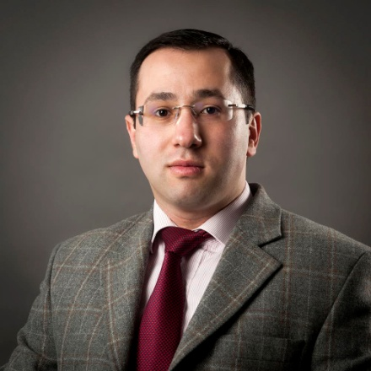

EDUCATION

01/2020 – 06/2021 Tufts University (Medford, MA, USA)
Fletcher School of Law and Diplomacy
Professional Exchange Program for Public Servants in Public Policy and Administration

06/2009 – 06/2012 Russian-Armenian University (Yerevan, Armenia)
PhD in Public Property Law

09/2015 – 06/2016 College of Europe (Bruges, Belgium)
Master in European Law (LLM)

10/2010 – 06/2012 University of Vincennes-Saint Denis (Paris, France)
Master in Health Law and Medical Law

09/2007 – 05/2009 Russian-Armenian University (Yerevan, Armenia)
Master in Business and Commercial Law

09/2003 – 06/2007 Russian-Armenian University (Yerevan, Armenia)
BA in Private Law

SUMMER /WINTER COURSES

01/2018 CEU school of Public Policy / Folke Bernadotte Academy (Sandö, Sweden)
Participant in the Young Policy Advisers Course for Eastern Partners

06/2017 OSCE / ODIHR - European Network of National Human Rights Institutions (ENNHRI) (Poznan, Poland)
Participant in the Academy for National Human Rights Institutions

08/2012 The Hague Academy of International Law (The Netherlands)
Participant in the summer School in Private International Law

PROFESSIONAL ACTIVITIES

09/2018 – present Russian-Armenia University (Yerevan, Armenia)
The Institute for Law and Politics
Academic Director of Health Law Master Program

09/2016 – present The Human Rights Defender’s (Parliamentary Ombudsman) Office (Yerevan, Armenia)
Head of Department for International Cooperation

10/2015 – 06/2016 European Health Parliament (Brussels, Belgium)
Member of Healthcare and Climate change committee

10/2014 – 08/2015 Ministry of Justice (Yerevan, Armenia)
Department for Relations with the European Court of Human Rights
Lead specialist in Human Rights

05/2014 – 06/2015 National Institution for Labor and Social Research (Yerevan, Armenia)
Lecturer of Social Human Rights for public service employees

09/2013 – 07/2018 Armenian State University of Economics (Yerevan, Armenia)
Assistant Professor for Financial and Economic Law

06/2014 – 10/2014 European Union Delegation to Armenia (Yerevan, Armenia)

Armenian Hakastver Human Rights NGO

Lawyer within a Group of experts

01/2013 – 01/2015 Yerevan State Medical University (Yerevan, Armenia)
Assistant Professor for Health law

09/2009 – 06/2012 Russian-Armenian University (Yerevan, Armenia)
Teaching Assistant for Civil Law

04/2010 – 09/2010 Friedrich Ebert German Foundation, Armenian Branch (Yerevan, Armenia)
Lawyer within a Group of experts

09/2009 – 06/2010 Russian-Armenian University (Yerevan, Armenia)
In-house lawyer (Litigation Unit)

MEMBERSHIP

Since 05/2017 Armenian Lawyers Association (Yerevan, Armenia)
Member of association

Since 06/2016 Bruges City Municipality (Bruges, Belgium)
Honoris Causa

Since 09/2014 UNESCO Chair in Bioethics (Haifa, Israel)
Member of the International Forum of Teachers
Author of around 40 publications in specialized International reviews (Armenia, Russia, Ukraine, Italy, and Israel), coauthor of two legal manuals.

Scholarships awarded by: Tavitian foundation (2020), the European Commission ENP (2015-2016); The Hague Academy of International Law (August 2012); French Government (2011-2012); Association of Law Institutes of Commonwealth of Independent States based in Moscow (1st prize) (February 2008).

LANGUAGES SKILLS

Armenian, English, French, Russian.

